**Question:**

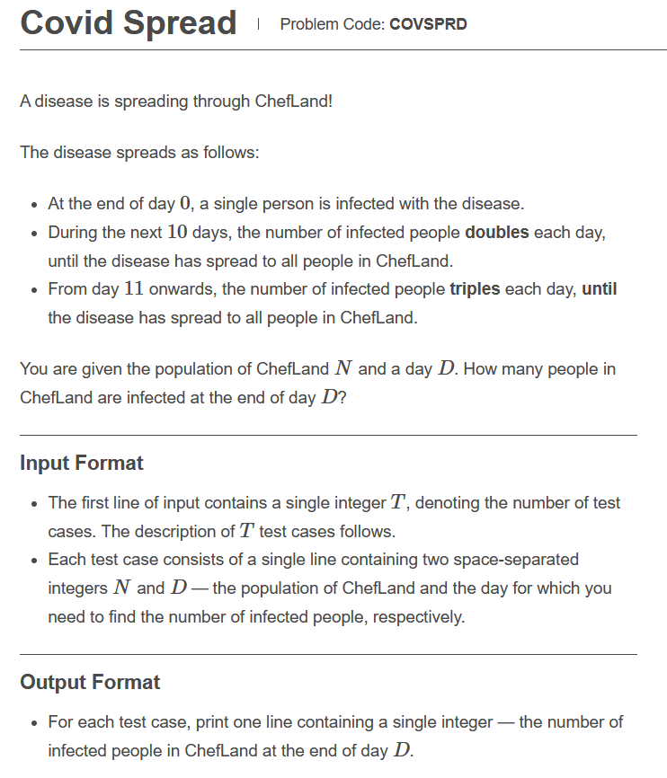

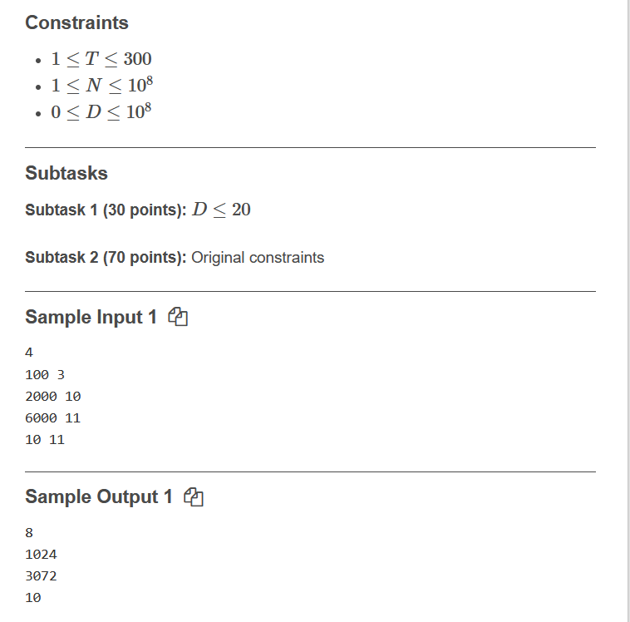

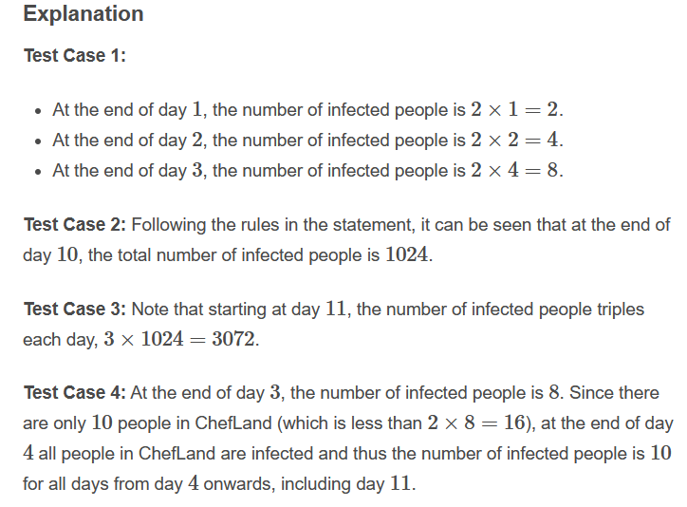

**Link:** [**https://www.codechef.com/JAN221C/problems/COVSPRD**](https://www.codechef.com/JAN221C/problems/COVSPRD)

**Code:**

**#include<bits/stdc++.h>**

**using namespace std;**

**int main()**

**{**

**int input;**

**cin>>input;**

**int n,d,dd=0;**

**for(int i=0;i<input;i++)**

**{**

**cin>>n>>d;**

**if(d<=10)**

**{**

**dd=pow(2,d);**

**}**

**else**

**{**

**dd=1024*pow(3,(d-10));**

**}**

**if(d<=20)**

**{**

**cout<<min(n,dd)<<endl;**

**}**

**else**

**{**

**cout<<n<<endl;**

**}**

**}**

**return 0;**

**}**

**Solution: Correct(100 point)**